***LED FLASHER***

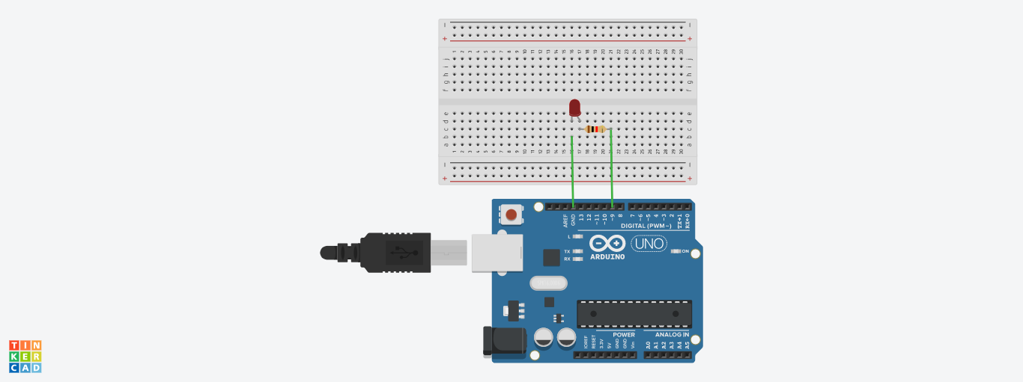

* ***THEORY:***

In this project, we will go over how to build an Arduino LED flasher circuit.

We will use a standard Arduino board, doesn't matter which, and connect it so that it flashes an LED a certain amounts of times on and off repeatedly to create an LED flasher circuit.

An Arduino is a self-contained microcontroller. Therefore, it can be programmed via the language processing to turn the LED on for a certain period of time and turn it off for a certain period of time- over and over. To control the amount of time the LED will be on and the amount of time it will be off can easily be decided by our software code.

Once the Arduino board is connected to a computer via USB, it has 5V of power. It gets power via the USB. The LED is then connected to its digital output pin. All we must then do is write our program which flashes the LED on and off.

* ***CONCEPTS USED:***

1. Knowledge about Aurdino UNO
2. Coding for aurdino
3. Breadboard circuits

* ***LEARNING AND OBSERVATIONS:***

1. Connections in Breadboard and wiring.

2. How to control arduino and its coding.

3. Use of multimeter for continuity.

***OBSERVATION:***

**1.** Blinking of an LED.

2. Relation between software and hardware.

***PROBLEMS & TROUBLESHOOTING:***

1. To select the right port and type of arduino
2. To check the loose connections
3. To check the connections according to the codes
4. To check the continuity of the circuit
5. To check the flow of current in the circuit

***PRECAUTIONS:***

1. Handle tools carefully
2. Wear gloves
3. Do not connect arduino till the circuit is complete

***OUTCOMES:***

1. On and off of an LED
2. Used in project works